COINS-Constantine I (306-337)-AE3-Trier

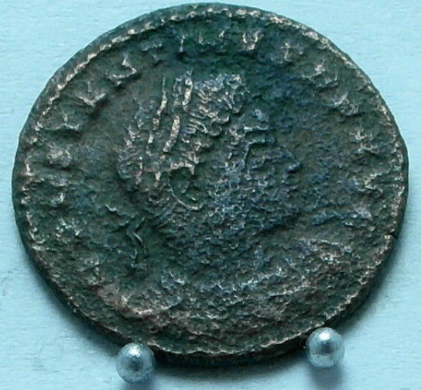 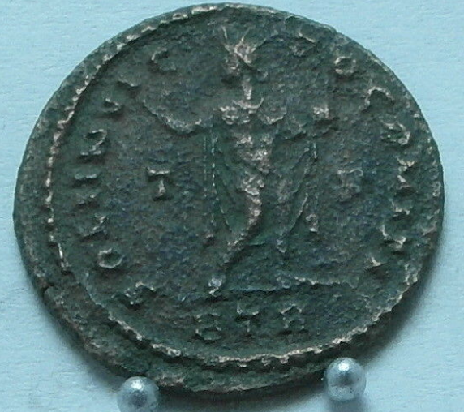

CONSTAN-TINVS AVG. Laureate bust right, seen from behind.. SOLI INVICTO COMITI. Sol standing right, head to left. Holding a globe.  
BTR-mintmark. T-F across fields. RIC VII 135,B. AE3 Treveri, 1st officina, AD 323/4. O: CONSTAN-TINVS AVG. Laureate bust right, seen from behind. Good Very Fine, green patina.

*... The Sarmatians first attacked a city which had a constant garrison, where the part of the wall near the ground was built of stone and the upper parts in wood. The Sarmatians thought they could easily conquer the city, if they could set the wooden part of the wall on fire, so they lit a fire and shot the people on the walls. But while these people returned fire with darts and arrows, Constantine attacked them from behind, taking them by surprise, killing many and taking numerous prisoners, while the survivors fled...*  (Zosimus, *New History*, 2.21.1-2)